**Assessment Cover Page**

|  |  |
| --- | --- |
| *Student Full Name* | Santhosh Shanmugasundaram |
| *Student Number* | Sba24100 |
| *Module Title* | AI Concepts to Implementation |
| *Assessment Title* | CA2 |
| *Assessment Due Date* | 5th January 2025 |
| *Date of Submission* | 5th January 2025 |

**Declaration**

By submitting this assessment, I confirm that I have read the CCT policy on academic misconduct and understand the implications of submitting work that is not my own or does not appropriately reference material taken from a third party or other source.

I declare it to be my own work and that all material from third parties has been appropriately referenced.

I further confirm that this work has not previously been submitted for assessment by myself or someone else in CCT College Dublin or any other higher education institution.

CA1 – AI Concepts to Implementation

Contents

1. Question1: Min-Max Algorithm with Alpha Beta Pruning. 1

1.1 Task1a: Determine Min-Max Value 1

1.2 Task1b: Determine Pruned Nodes using Alpha Beta Pruning Technique 3

1.3 Task1c: Determine Alpha Beta value 4

1.4 Task1d: Python program 4

1.5 Min-Max Searching 5

1.6 Alpha-Beta Pruning 5

1.6.1 Key Terminologies 6

1.6.2 Key Steps 6

1.6.3 Condition for Pruning 6

2 References 6

3 GitHub Link 7

# Question1: Min-Max Algorithm with Alpha Beta Pruning.

## Task1a: Determine Min-Max Value

Task is to implement the min-max algorithm for the below tree and find the values at each node.

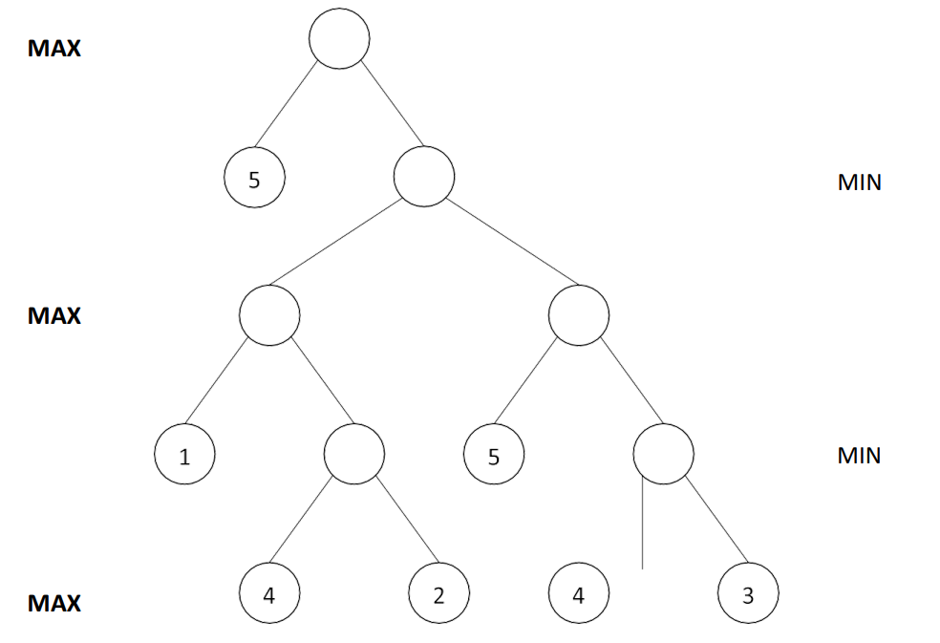

The Min-Max algorithm involves several key steps, executed recursively until the optimal move is determined. This algorithm applies Depth First Search (DFS); therefore, we must go till the terminal node. Each step involved in execution of min-max algorithm for the above tree is listed below and to start with, each node has been named from A to F starting from leaf node at bottom to top.

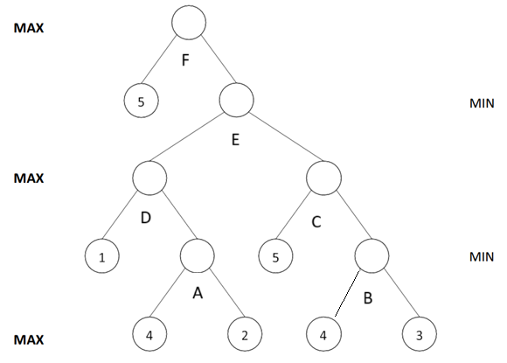

1. Start from leaf node, which is at the bottom, let’s try to compare the leaf values corresponding to node A.
2. Since node A and B corresponds to min node, we try to fetch the lowest of value from its associated leaf value.
3. Therefore, A is assigned as 2 (lowest of 4 & 2) and B is assigned as 3 (lowest of 4 and 3).
4. Next nodes are D and C which corresponds to Max node; therefore, we try to fetch the highest value from its associated child node/leaf node.
5. Node D is assigned as 2 (highest of 1 & 2) and C get’s 5 (highest of 5 & 3).
6. Node E corresponds to Min node; therefore, we take the lowest of D and C which results in value 2 (lowest of 2 & 5).
7. Now we arrive to the topmost/root node of the tree which contains a leaf node with value 5 and child node E whose value is 2. Taking the max value of 5 and 2, we assign 5 to F.

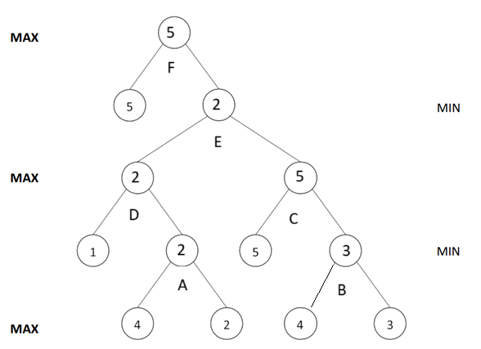

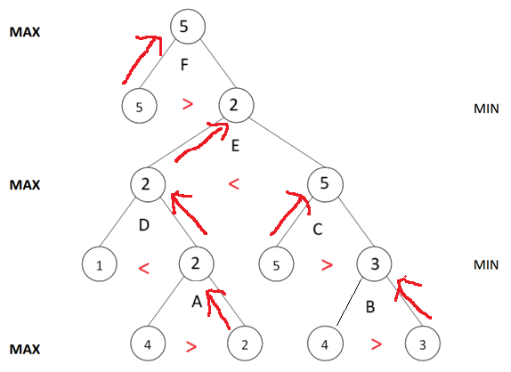

## Task1b: Determine Pruned Nodes using Alpha Beta Pruning Technique

Alpha-beta pruning is a technique used to improve the efficiency of the minimax algorithm by eliminating the evaluation of certain nodes that has no significance to the result.

**Alpha (α)**:   
Represents the best value the maximizing player can guarantee so far. The initial value of alpha is -Infinity (-∞).

**Beta**: Represents the best value the minimizing player can guarantee so far. The initial value of Beta is +Infinity (+∞)

Condition for Pruning

* The minimizing player finds a value that is lower than or equal to alpha (β ≤ α) then prune the branch.
* The maximizing player can prune a branch when they find a value higher than or equal to beta (α ≥ β)

Steps:

1. Start from top node F where alpha is set to -∞ and beta to ∞.
2. Check the child node of F and set value as alpha to 5.
3. Move to node E to D and get value of 1.
4. Move to node A and get value of value beta as 4. Since beta value of 4 is less than alpha value of 5, prune the remaining child of A.
5. Move again to node E where pruning condition meets, therefore prune remaining child of E.

Solution:

For the provided tree, following nodes are pruned,

Child 2 of node A  
Right side of node E, which is C & B

## Task1c: Determine Alpha Beta value

Final value of Alpha and Beta at each node is as below,

1. Node F: α = 5 and β = ∞.
2. Node E: α = 5 and β = 4.
3. Node D: α = 5 and β = ∞.
4. Node A: α = 5 and β = 4.

## Task1d: Python program

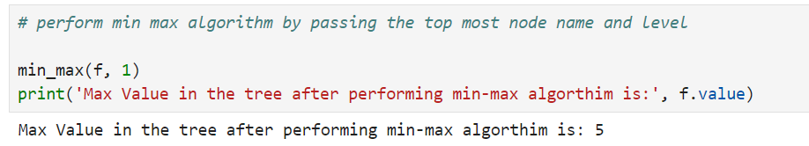

The python program result below, shows the list of nodes that were activated when using Alpha beta pruning. It does not contain nodes that are pruned.

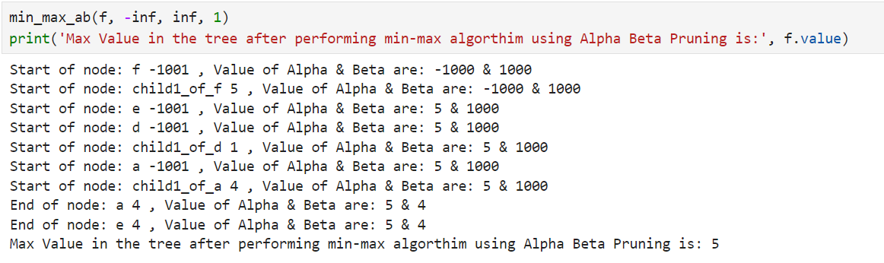

# Question2:

# Question3:

# References

(Degni)

Degni, Riccardo. “The Ultimate Checkmate: AI and Chess Engines.” *Codemotion Magazine*, 20 Feb. 2023, www.codemotion.com/magazine/ai-ml/the-ultimate-checkmate-ai-and-chess-engines/.

Available at:   
<https://www.codemotion.com/magazine/ai-ml/the-ultimate-checkmate-ai-and-chess-engines/>

(GeeksforGeeks)

GeeksforGeeks. “Mini-Max Algorithm in Artificial Intelligence.” *GeeksforGeeks*, GeeksforGeeks, 27 June 2024, www.geeksforgeeks.org/mini-max-algorithm-in-artificial-intelligence/.

Available at:   
<https://www.geeksforgeeks.org/mini-max-algorithm-in-artificial-intelligence/>

(Saxena)

Saxena, Abhimanyu. “Alpha Beta Pruning in Artificial Intelligence.” *Applied AI Blog*, 25 Sept. 2024, www.appliedaicourse.com/blog/alpha-beta-pruning-in-artificial-intelligence/. Accessed 9 Nov. 2024.

Available at:   
<https://www.appliedaicourse.com/blog/alpha-beta-pruning-in-artificial-intelligence/>

# GitHub Link

<https://github.com/santhosh-sba24100/CA1---AI-Concepts-to-Implementation>